# Objectives

* Explain about conditional rendering in React
* Define element variables
* Explain how to prevent components from rendering

In this hands-on lab, you will learn how to:

* Implement conditional rendering in React applications

# Prerequisites

The following is required to complete this hands-on lab:

* Node.js
* NPM
* Visual Studio Code

# Notes

Estimated time to complete this lab: **60 minutes.**

Create a React Application named “ticketbookingapp” where the guest user can browse the page

where the flight details are displayed whereas the logged in user only can book tickets.

The Login and Logout buttons should accordingly display different pages. Once the user is logged in the User page should be displayed. When the user clicks on Logout, the Guest page should be displayed.

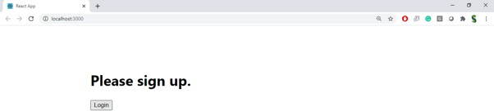

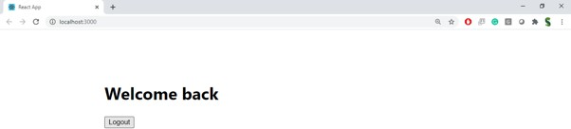

# Hint:

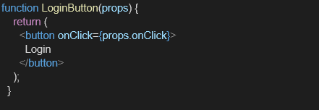

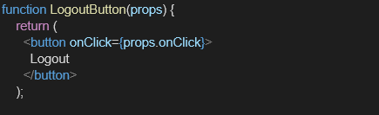

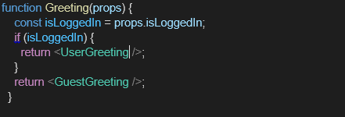

**UserGreeting.js**

import React from 'react';

function UserGreeting() { return (

<div>

<h2>Welcome, User!</h2>

<p>You can now book your flight tickets below:</p>

<button>Book Ticket</button>

</div>

);

}

# GuestGreeting.js

export default UserGreeting;

import React from 'react';

function GuestGreeting() { return (

<div>

<h2>Welcome, Guest!</h2>

<p>Here are the available flight details:</p>

<ul>

<li>`7?÷ Chennai → Delhi - 8:00 AM</li>

<li>`?÷7 Mumbai → Bangalore - 11:30 AM</li>

<li>?7`÷ Kolkata → Hyderabad - 5:00 PM</li>

</ul>

<p>Login to book tickets.</p>

</div>

);

}

export default GuestGreeting;

# Greeting.js

import React from 'react';

import UserGreeting from './UserGreeting'; import GuestGreeting from './GuestGreeting';

function Greeting(props) {

const isLoggedIn = props.isLoggedIn; if (isLoggedIn) {

return <UserGreeting />;

}

return <GuestGreeting />;

}

export default Greeting;

# LoginButton.js

import React from 'react';

function LoginButton(props) { return (

<button onClick={props.onClick}> Login

</button>

);

}

export default LoginButton;

# LogoutButton.js

import React from 'react';

function LogoutButton(props) { return (

<button onClick={props.onClick}> Logout

</button>

);

}

export default LogoutButton;

